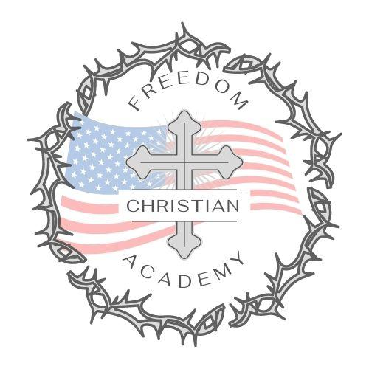
Freedom Christian Academy
505 Ward Ave, Erskine, MN 56535
We are an Inter-denominational Christian school giving children the opportunity to learn in an environment where their education is based upon strong, biblical values and concepts.
Tuition
Christian financial stewardship is essential in order for FCA to operate successfully.
Children enrolled | 12 payments (begin in June) | 9 payments (begin in Sept.) | 1 annual payment. (By Sept.1st)
1 | $334. | $445. | $4,000.
2 | $625. | $834. | $7,500.
3 | $834. | $1112. | $10,000.
4 | $1000. | $1334. | $12,000.
5 | $1167. | $1556. | $14,000.
Same figures - Break down per child:
 | 12 payments | 9 payments | Annual
1st child | $334. | $445. | $4000.
2nd child | $292. | $389. | $3500.
3rd child | $209. | $278. | $2500.
4th child | $167. | $223. | $2000.
5th child | $167. | $223. | $2000.
Division of FHL Academy, INC

